

**FLY AWAY PLUS**

**DETAIL DESIGN DOCUMENT**

**Class Design**

**Project Code: FAP**

**Document Code: FAP_Class Design_v1.0_EN**

**Record of Change**

*A-Added M-Modified D-Deleted

|  |  |  |  |  |
| --- | --- | --- | --- | --- |
| Date | Item | A, M, D* | Change Description | Version |
| 2015/08/14 | Add new | A |  | V1.0 |

Table of Contents

1 Introduction 5

1.1. Purpose 5

1.2. Definitions, Acronyms and Abbreviations 5

2 Packages 5

2.1. Search 6

2.1.1. Class Diagram 6

2.1.2. User Class 6

2.1.3. Photo Class 7

2.1.4. Place Class 7

2.1.5. SearchController class 7

2.1.6. Sequence Diagram 8

2.2. Help Center (Undone) 9

2.3. Suggest (Undone) 9

2.4. Post Management 9

2.4.1. Class Diagram 9

2.4.2. User Class 9

2.4.3. Photo Class 10

2.4.4. Place Class 10

2.4.5. Post Class 11

2.4.6. Post Controller Class 11

2.4.7. Sequence Diagram 12

2.5. Share Management (Undone) 13

2.6. Comment Management 13

2.6.1. Class Diagram 13

2.6.2. User Class 14

2.6.3. Post Class 14

2.6.4. User Controller Class 15

2.6.5. Sequence Diagram 15

2.7. Like Management 17

2.7.1. Class Diagram 17

2.7.2. User Class 17

2.7.3. Post Class 18

2.7.4. User Controller Class 18

2.7.5. Sequence Diagram 19

2.8. Report 21

2.8.1. Class Diagram 21

2.8.2. User Class 21

2.8.3. ReportPost Class 22

2.8.4. ReportUser Class 22

2.8.5. Sequence Diagram 23

2.9. Chat 24

2.9.1. Class Diagram 24

2.9.2. User Class 24

2.9.3. Conversation Class 25

2.9.4. User Controller Class 25

2.9.5. Sequence Diagram 26

2.10. Friend Management 27

2.10.1. Class Diagram 27

2.10.2. User Class 27

2.10.3. User Controller Class 28

2.10.4. Sequence Diagram 29

2.11. Room (Undone) 30

2.12. Account Management 30

2.12.1. Class Diagram 30

2.12.2. User Class 30

2.12.3. Login Controller Class 31

2.12.4. Sequence Diagram 31

# Introduction

## Purpose

Fly Away Plus class design document contains descriptions of all classes of the Fly Away Plus. It includes:

* Class diagrams that describe the static relation of all classes in the system.

## Definitions, Acronyms and Abbreviations

|  |  |  |
| --- | --- | --- |
| Abbreviations | Description | Comment |
| FAP | Fly Away Plus |  |
| FAQ | Frequently Asked Question |  |

# Packages

|  |  |  |  |
| --- | --- | --- | --- |
| No. | Packages | Language | Description |
|  | Search | C# |  |
|  | Help Center | C# | Contain help content, FAQ and using guides |
|  | Suggest | C# | Create suggestion based on user activities history |
|  | Personal Page | C# | Contain user’s personal page: New feed, Timeline, Post, … |
|  | Post Management | C# | Contain information and data which related to posts |
|  | Share Management | C# | Share FAP contents to other social networks |
|  | Comment Management | C# | Contain information of comments |
|  | Like Management | C# | User create a rating to a post, includes: Like and Dislike |
|  | Report | C# | Contain reports which user created and sent to Admin |
|  | Chat | C# | Contain messages which user sent to others |
|  | Friend Management | C# | Contain user’s friend list and friend request |
|  | Room | C# | Contain room which user created |
|  | Login | C# | Contain user’s login information |
|  | Manage Member’s Account | C# | Contain Admin’s function, is used to handle reports which was sent by user |

## Search

### Class Diagram

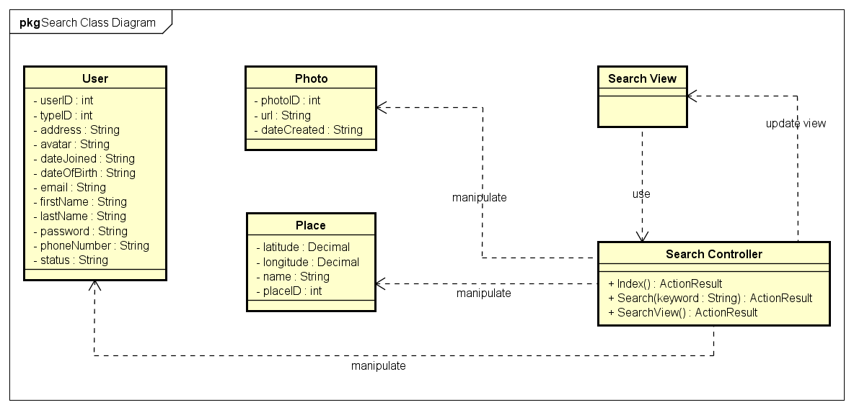

*Search Class Diagram*

|  |  |  |
| --- | --- | --- |
| No. | Class Name | Description |
|  | User | Include method interact with Database |
|  | Photo | Include method interact with Database |
|  | Place | Include method interact with Database |
|  | Search | Include method interact with Controller |
|  | Search Controller | Include method interact with Model |

### User Class

#### Attributes

|  |  |  |  |  |  |
| --- | --- | --- | --- | --- | --- |
| No | Attributes | Type | Default | Note | Description |
|  | userID | int |  | public | User’s ID |
|  | typeID | int |  | public | User’s type, includes: Normal, Facebook, Google+ registered |
|  | address | String |  | public | User’s address |
|  | avatar | String |  | public | User’s avatar image |
|  | dateJoined | String |  | public | User’s joined date. Auto-created while registering |
|  | dateOfBirth | String |  | public | User’s date of birth |
|  | email | String |  | public | User’s email |
|  | firstName | String |  | public | User’s first name |
|  | lastName | String |  | public | User’s last name |
|  | password | String |  | public | User’s password |
|  | phoneNumber | String |  | public | User’s phone number |
|  | status | String |  | public | User’s status, includes: Lock and Active |

#### Methods

|  |  |  |  |  |
| --- | --- | --- | --- | --- |
| No. | Method | Input | Return | Description |
|  |  |  |  |  |

### Photo Class

#### Attributes

|  |  |  |  |  |  |
| --- | --- | --- | --- | --- | --- |
| No | Attributes | Type | Default | Note | Description |
|  | photoID | int |  |  | Photo’s ID |
|  | url | String |  |  | Photo’s URL |
|  | dateCreated | String |  |  | Photo’s created date. Auto-created while uploading |

#### Methods

|  |  |  |  |  |
| --- | --- | --- | --- | --- |
| No. | Method | Input | Return | Description |
|  |  |  |  |  |

### Place Class

#### Attributes

|  |  |  |  |  |  |
| --- | --- | --- | --- | --- | --- |
| No | Attributes | Type | Default | Note | Description |
|  | placeID | int |  |  | Place’s ID |
|  | name | String |  |  | Place’s name |
|  | latitude | Decimal |  |  | Place’s latitude |
|  | longitude | Decimal |  |  | Place’s longitude |

#### Methods

|  |  |  |  |  |
| --- | --- | --- | --- | --- |
| No. | Method | Input | Return | Description |
|  |  |  |  |  |

### SearchController class

#### Attributes

|  |  |  |  |  |  |
| --- | --- | --- | --- | --- | --- |
| No | Attributes | Type | Default | Note | Description |
|  |  |  |  |  |  |

#### Methods

|  |  |  |  |  |
| --- | --- | --- | --- | --- |
| No. | Method | Input | Return | Description |
|  | Index |  | ActionResult | Display Search page |
|  | Search | String | ActionResult | Search a keyword |
|  | SearchDetail |  | ActionResult | Display Search Result page |

### Sequence Diagram

#### UC001-Search by name

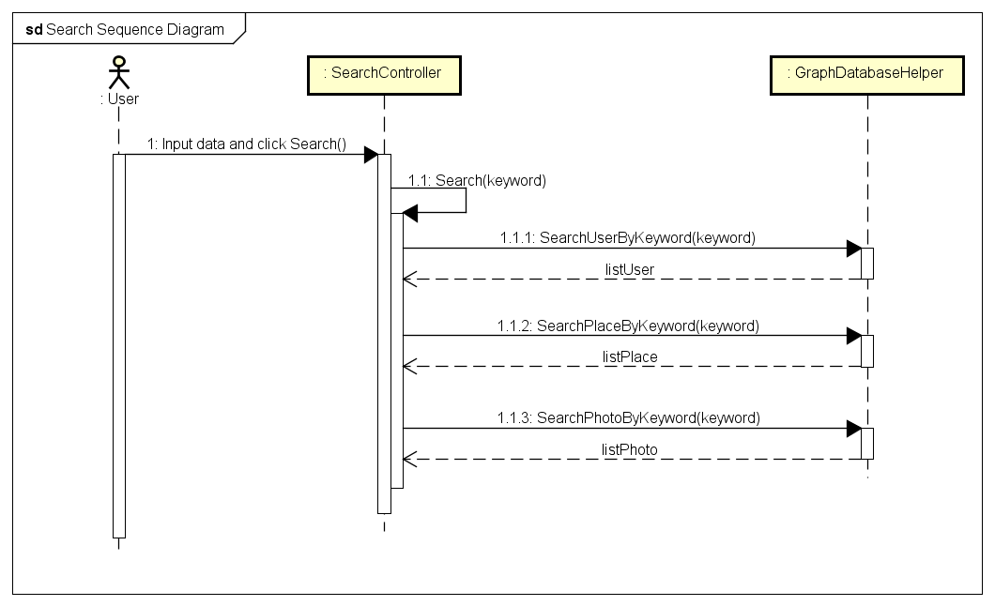

*Search Sequence Diagram*

## Help Center (Undone)

## Suggest (Undone)

## Post Management

### Class Diagram

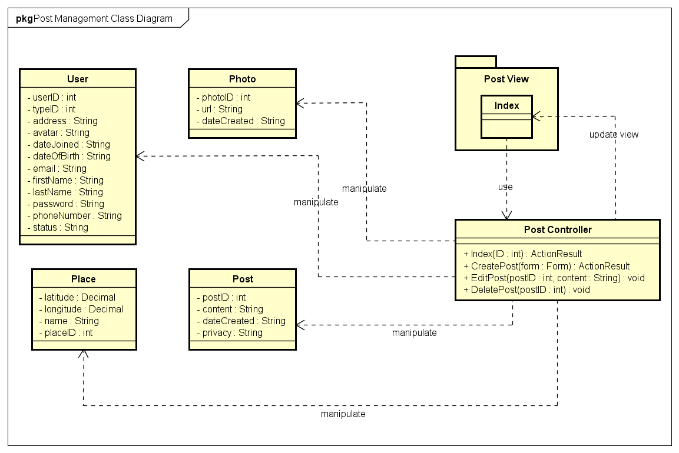

*Post Management Class Diagram*

|  |  |  |
| --- | --- | --- |
| No. | Class Name | Description |
|  | User | Include method interact with Database |
|  | Photo | Include method interact with Database |
|  | Place | Include method interact with Database |
|  | Index | Include method interact with Controller |
|  | Post Controller | Include method interact with Model |

### User Class

#### Attributes

|  |  |  |  |  |  |
| --- | --- | --- | --- | --- | --- |
| No | Attributes | Type | Default | Note | Description |
|  | userID | int |  | public | User’s ID |
|  | typeID | int |  | public | User’s type, includes: Normal, Facebook, Google+ registered |
|  | address | String |  | public | User’s address |
|  | avatar | String |  | public | User’s avatar image |
|  | dateJoined | String |  | public | User’s joined date. Auto-created while registering |
|  | dateOfBirth | String |  | public | User’s date of birth |
|  | email | String |  | public | User’s email |
|  | firstName | String |  | public | User’s first name |
|  | lastName | String |  | public | User’s last name |
|  | password | String |  | public | User’s password |
|  | phoneNumber | String |  | public | User’s phone number |
|  | status | String |  | public | User’s status, includes: Lock and Active |

#### Methods

|  |  |  |  |  |
| --- | --- | --- | --- | --- |
| No. | Method | Input | Return | Description |
|  |  |  |  |  |

### Photo Class

#### Attributes

|  |  |  |  |  |  |
| --- | --- | --- | --- | --- | --- |
| No | Attributes | Type | Default | Note | Description |
|  | photoID | int |  |  | Photo’s ID |
|  | url | String |  |  | Photo’s URL |
|  | dateCreated | String |  |  | Photo’s created date. Auto-created while uploading |

#### Methods

|  |  |  |  |  |
| --- | --- | --- | --- | --- |
| No. | Method | Input | Return | Description |
|  |  |  |  |  |

### Place Class

#### Attributes

|  |  |  |  |  |  |
| --- | --- | --- | --- | --- | --- |
| No | Attributes | Type | Default | Note | Description |
|  | placeID | int |  |  | Place’s ID |
|  | name | String |  |  | Place’s name |
|  | latitude | Decimal |  |  | Place’s latitude |
|  | longitude | Decimal |  |  | Place’s longitude |

#### Methods

|  |  |  |  |  |
| --- | --- | --- | --- | --- |
| No. | Method | Input | Return | Description |
|  |  |  |  |  |

### Post Class

#### Attributes

|  |  |  |  |  |  |
| --- | --- | --- | --- | --- | --- |
| No | Attributes | Type | Default | Note | Description |
|  | postID | int |  |  | Post’s ID |
|  | content | String |  |  | Post’s content |
|  | dateCreated | String |  |  | Post’s created date. Auto-created while creating post |
|  | privacy | String |  |  | Post’s privacy |

#### Methods

|  |  |  |  |  |
| --- | --- | --- | --- | --- |
| No. | Method | Input | Return | Description |
|  |  |  |  |  |

### Post Controller Class

#### Attributes

|  |  |  |  |  |  |
| --- | --- | --- | --- | --- | --- |
| No | Attributes | Type | Default | Note | Description |
|  |  |  |  |  |  |

#### Methods

|  |  |  |  |  |
| --- | --- | --- | --- | --- |
| No. | Method | Input | Return | Description |
|  | Index |  | ActionResult | Display Search page |
|  | Search | String | ActionResult | Search a keyword |
|  | SearchDetail |  | ActionResult | Display Search Result page |

### Sequence Diagram

#### Add Post

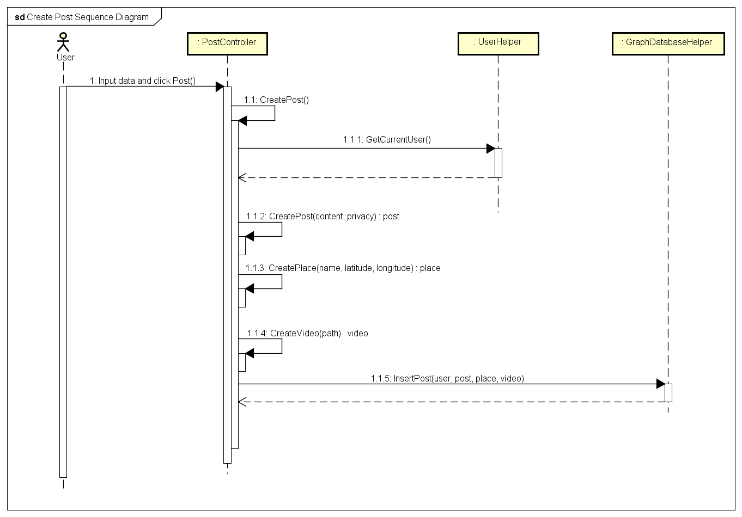

*Add Post Sequence Diagram*

#### Edit Post

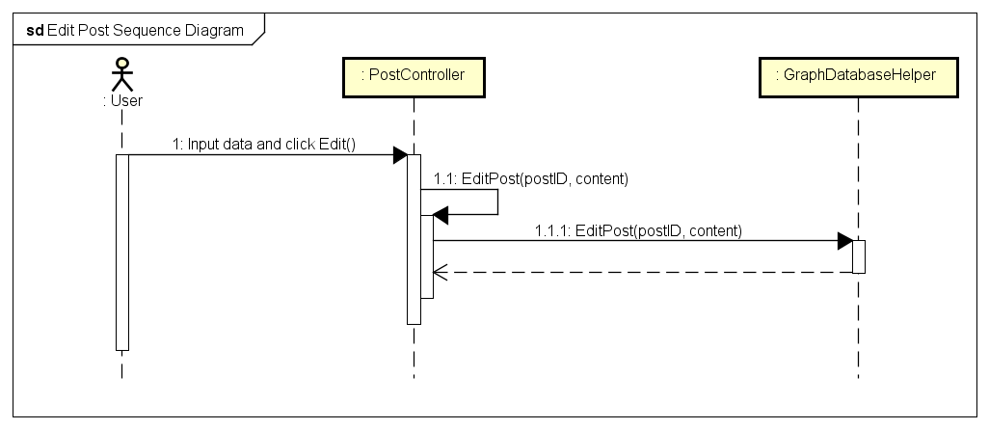

*Edit Post Sequence Diagram*

#### Delete Post

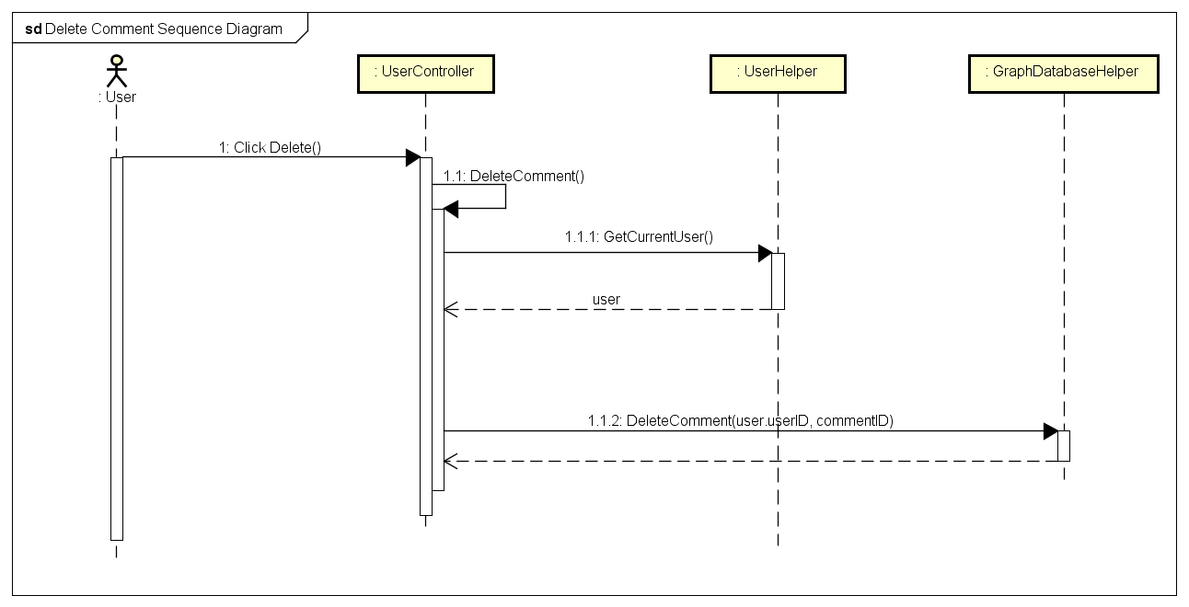

*Delete Post Sequence Diagram*

## Share Management (Undone)

## Comment Management

### Class Diagram

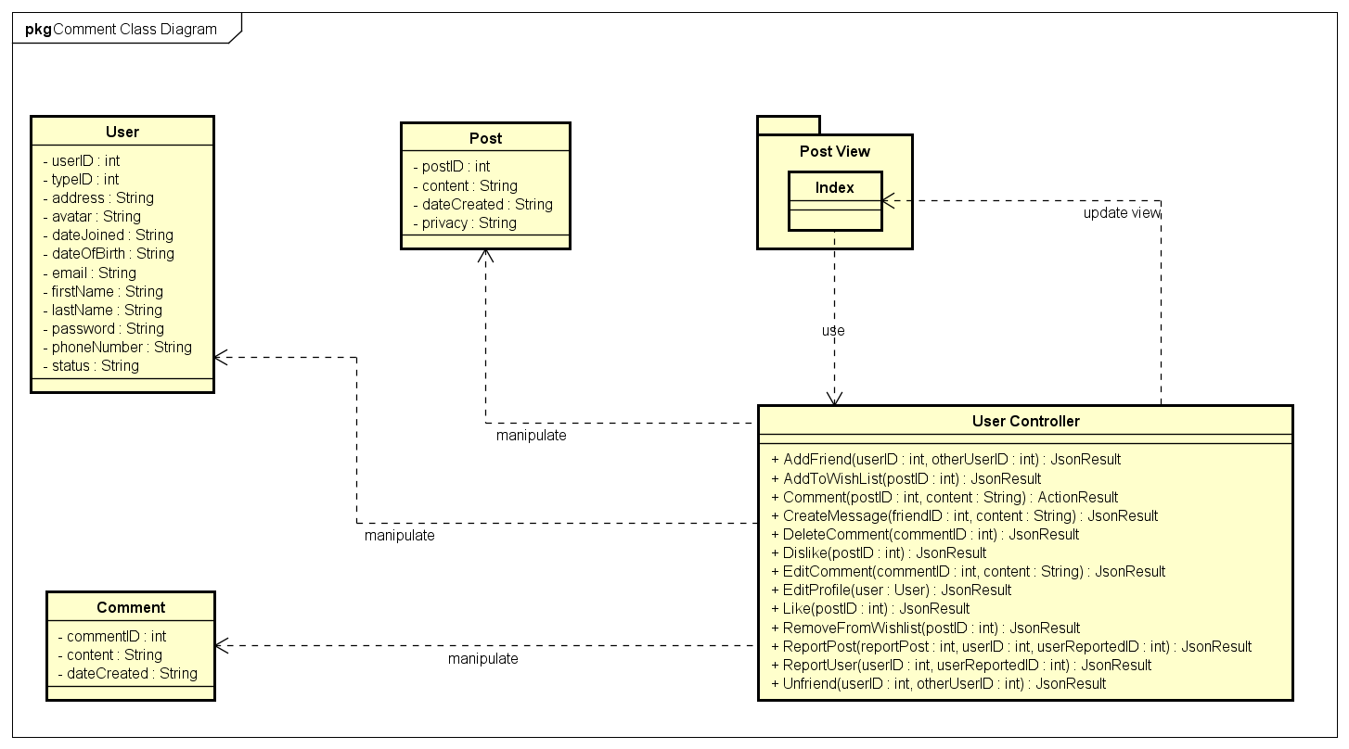

*Comment Management Class Diagram*

|  |  |  |
| --- | --- | --- |
| No. | Class Name | Description |
|  | User | Include method interact with Database |
|  | Post | Include method interact with Database |
|  | Comment | Include method interact with Database |
|  | Index | Include method interact with Controller |
|  | User Controller | Include method interact with Model |

### User Class

#### Attributes

|  |  |  |  |  |  |
| --- | --- | --- | --- | --- | --- |
| No | Attributes | Type | Default | Note | Description |
|  | userID | int |  | public | User’s ID |
|  | typeID | int |  | public | User’s type, includes: Normal, Facebook, Google+ registered |
|  | address | String |  | public | User’s address |
|  | avatar | String |  | public | User’s avatar image |
|  | dateJoined | String |  | public | User’s joined date. Auto-created while registering |
|  | dateOfBirth | String |  | public | User’s date of birth |
|  | email | String |  | public | User’s email |
|  | firstName | String |  | public | User’s first name |
|  | lastName | String |  | public | User’s last name |
|  | password | String |  | public | User’s password |
|  | phoneNumber | String |  | public | User’s phone number |
|  | status | String |  | public | User’s status, includes: Lock and Active |

#### Methods

|  |  |  |  |  |
| --- | --- | --- | --- | --- |
| No. | Method | Input | Return | Description |
|  |  |  |  |  |

### Post Class

#### Attributes

|  |  |  |  |  |  |
| --- | --- | --- | --- | --- | --- |
| No | Attributes | Type | Default | Note | Description |
|  | postID | int |  |  | Post’s ID |
|  | content | String |  |  | Post’s content |
|  | dateCreated | String |  |  | Post’s created date. Auto-created while creating post |
|  | privacy | String |  |  | Post’s privacy |

#### Methods

|  |  |  |  |  |
| --- | --- | --- | --- | --- |
| No. | Method | Input | Return | Description |
|  |  |  |  |  |

### User Controller Class

#### Attributes

|  |  |  |  |  |  |
| --- | --- | --- | --- | --- | --- |
| No | Attributes | Type | Default | Note | Description |
|  |  |  |  |  |  |

#### Methods

|  |  |  |  |  |
| --- | --- | --- | --- | --- |
| No. | Method | Input | Return | Description |
|  | AddFriend | int, int | JsonResult | Add other users to friend list to get news, notification and messages |
|  | AddToWishlist | String | JsonResult | Add a post to wish list |
|  | Comment | int, String | ActionResult | Create a comment |
|  | CreateMessage | int, String | JsonResult | Send message to others |
|  | DeleteComment | int | JsonResult | Delete an owned comment |
|  | Dislike | int | JsonResult | Mark a post as dislike |
|  | EditComment | int, String | JsonResult | Edit content of an owned comment |
|  | EditProfile | user | JsonResult | Edit personal information |
|  | Like | int | JsonResult | Mark a post as liked |
|  | RemoveFromWishlist | int | JsonResult | Remove a post from wish list |
|  | ReportPost | int, int, int | JsonResult | Report a rule violation post |
|  | ReportUser | int, int | JsonResult | Report a rule violation user |
|  | Unfriend | int, int | JsonResult | Remove an user from friend list |

### Sequence Diagram

#### Add Comment

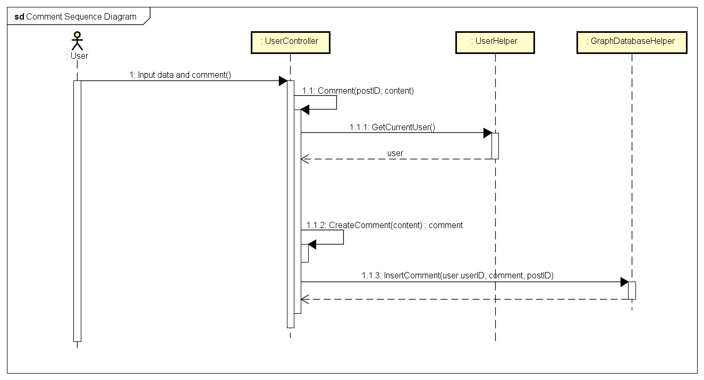

*Add Comment Sequence Diagram*

#### Edit Comment

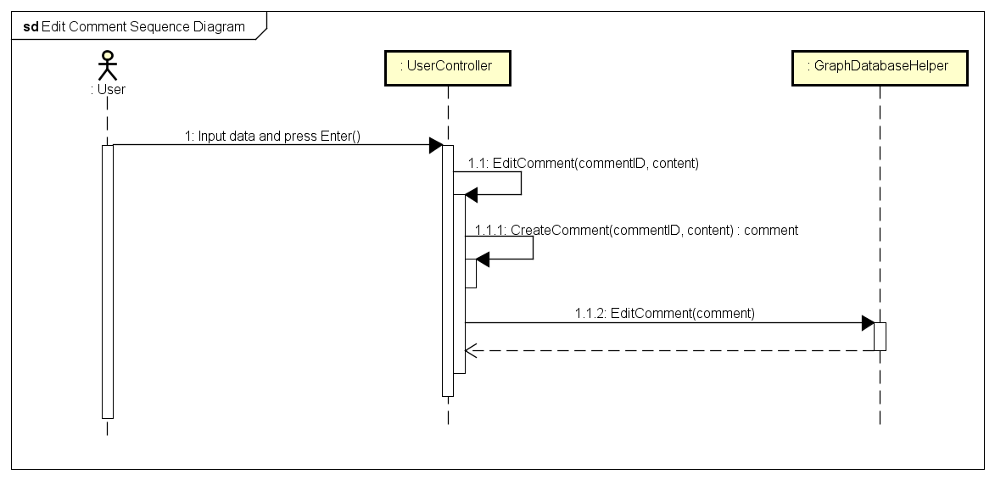

*Edit Comment Sequence Diagram*

#### Delete Comment



*Delete Comment Sequence Diagram*

## Like Management

### Class Diagram

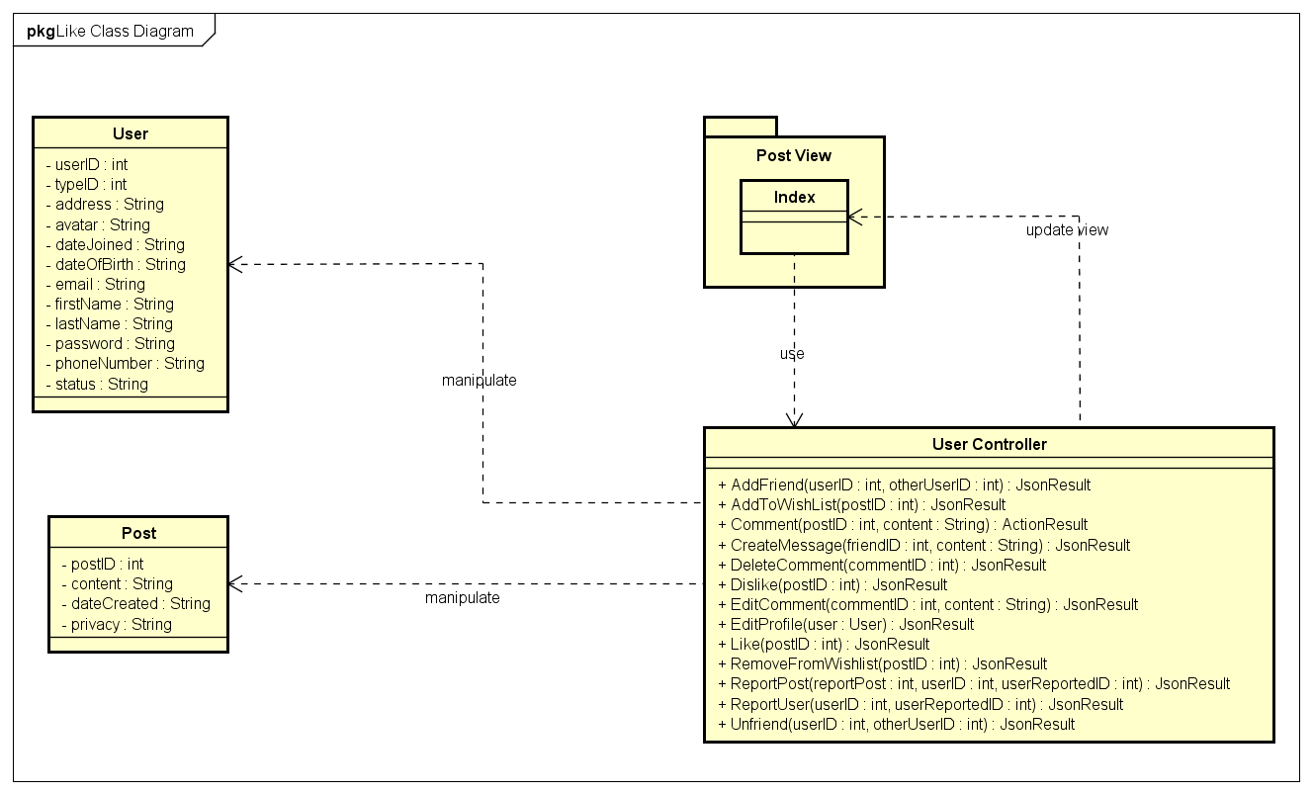

*Like Management Class Diagram*

|  |  |  |
| --- | --- | --- |
| No. | Class Name | Description |
|  | User | Include method interact with Database |
|  | Post | Include method interact with Database |
|  | Index | Include method interact with Controller |
|  | User Controller | Include method interact with Model |

### User Class

#### Attributes

|  |  |  |  |  |  |
| --- | --- | --- | --- | --- | --- |
| No | Attributes | Type | Default | Note | Description |
|  | userID | int |  | public | User’s ID |
|  | typeID | int |  | public | User’s type, includes: Normal, Facebook, Google+ registered |
|  | address | String |  | public | User’s address |
|  | avatar | String |  | public | User’s avatar image |
|  | dateJoined | String |  | public | User’s joined date. Auto-created while registering |
|  | dateOfBirth | String |  | public | User’s date of birth |
|  | email | String |  | public | User’s email |
|  | firstName | String |  | public | User’s first name |
|  | lastName | String |  | public | User’s last name |
|  | password | String |  | public | User’s password |
|  | phoneNumber | String |  | public | User’s phone number |
|  | status | String |  | public | User’s status, includes: Lock and Active |

#### Methods

|  |  |  |  |  |
| --- | --- | --- | --- | --- |
| No. | Method | Input | Return | Description |
|  |  |  |  |  |

### Post Class

#### Attributes

|  |  |  |  |  |  |
| --- | --- | --- | --- | --- | --- |
| No | Attributes | Type | Default | Note | Description |
|  | postID | int |  |  | Post’s ID |
|  | content | String |  |  | Post’s content |
|  | dateCreated | String |  |  | Post’s created date. Auto-created while creating post |
|  | privacy | String |  |  | Post’s privacy |

#### Methods

|  |  |  |  |  |
| --- | --- | --- | --- | --- |
| No. | Method | Input | Return | Description |
|  |  |  |  |  |

### User Controller Class

#### Attributes

|  |  |  |  |  |  |
| --- | --- | --- | --- | --- | --- |
| No | Attributes | Type | Default | Note | Description |
|  |  |  |  |  |  |

#### Methods

|  |  |  |  |  |
| --- | --- | --- | --- | --- |
| No. | Method | Input | Return | Description |
|  | AddFriend | int, int | JsonResult | Add other users to friend list to get news, notification and messages |
|  | AddToWishlist | String | JsonResult | Add a post to wish list |
|  | Comment | int, String | ActionResult | Create a comment |
|  | CreateMessage | int, String | JsonResult | Send message to others |
|  | DeleteComment | int | JsonResult | Delete an owned comment |
|  | Dislike | int | JsonResult | Mark a post as dislike |
|  | EditComment | int, String | JsonResult | Edit content of an owned comment |
|  | EditProfile | user | JsonResult | Edit personal information |
|  | Like | int | JsonResult | Mark a post as liked |
|  | RemoveFromWishlist | int | JsonResult | Remove a post from wish list |
|  | ReportPost | int, int, int | JsonResult | Report a rule violation post |
|  | ReportUser | int, int | JsonResult | Report a rule violation user |
|  | Unfriend | int, int | JsonResult | Remove an user from friend list |

### Sequence Diagram

#### Like

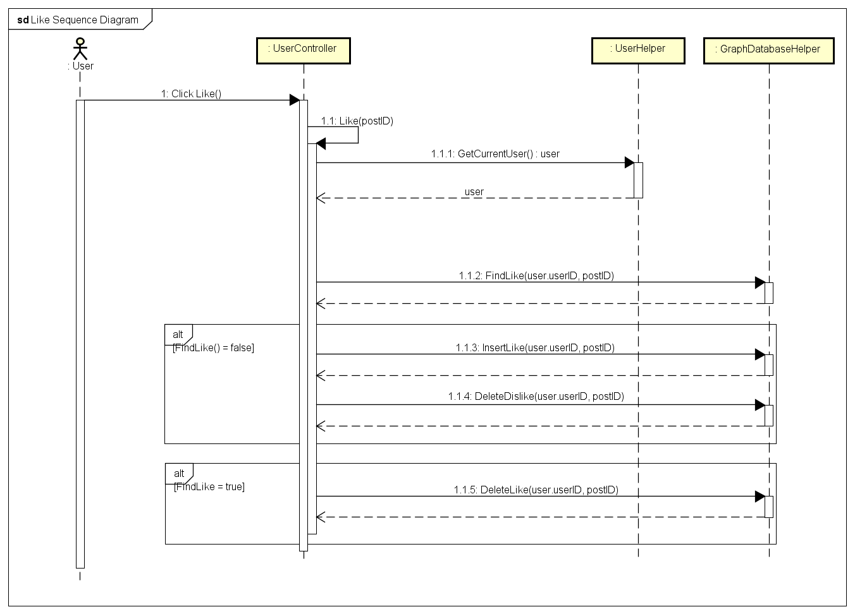

*Like Sequence Diagram*

#### Dislike

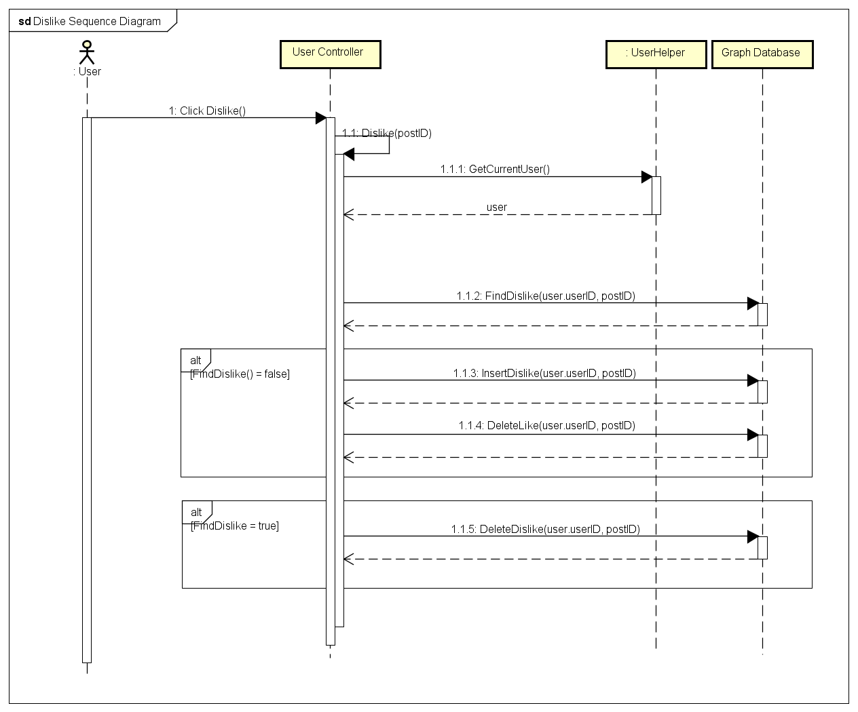

*Dislike Sequence Diagram*

## Report

### Class Diagram

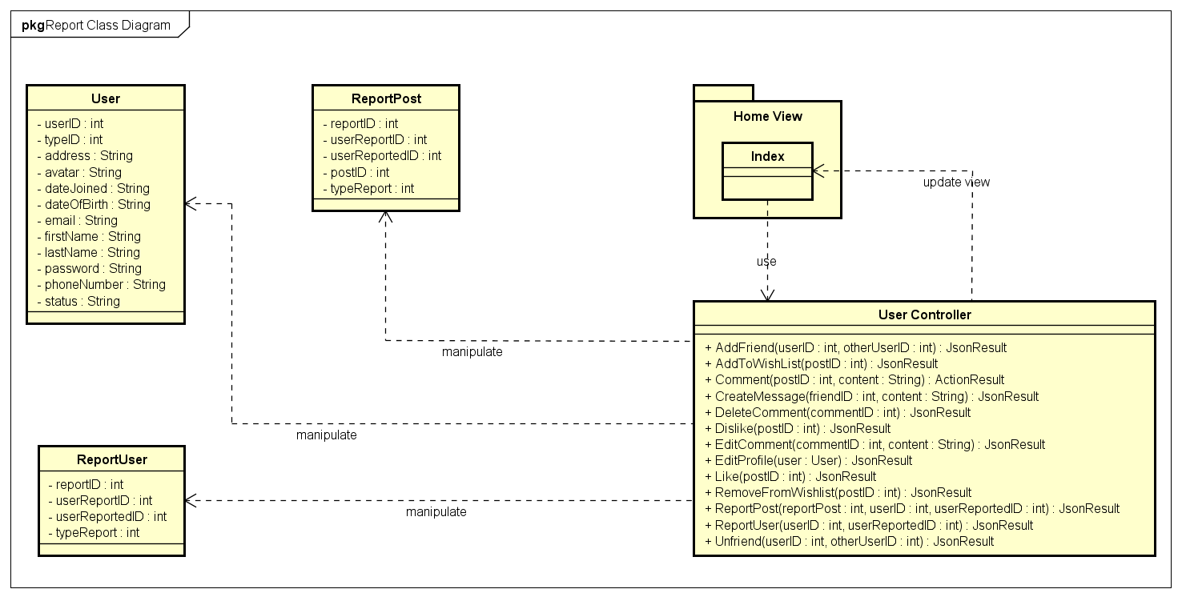

*Report Class Diagram*

|  |  |  |
| --- | --- | --- |
| No. | Class Name | Description |
|  | User | Include method interact with Database |
|  | ReportPost | Include method interact with Database |
|  | ReportUser | Include method interact with Database |
|  | Index | Include method interact with Controller |
|  | User Controller | Include method interact with Model |

### User Class

#### Attributes

|  |  |  |  |  |  |
| --- | --- | --- | --- | --- | --- |
| No | Attributes | Type | Default | Note | Description |
|  | userID | int |  | public | User’s ID |
|  | typeID | int |  | public | User’s type, includes: Normal, Facebook, Google+ registered |
|  | address | String |  | public | User’s address |
|  | avatar | String |  | public | User’s avatar image |
|  | dateJoined | String |  | public | User’s joined date. Auto-created while registering |
|  | dateOfBirth | String |  | public | User’s date of birth |
|  | email | String |  | public | User’s email |
|  | firstName | String |  | public | User’s first name |
|  | lastName | String |  | public | User’s last name |
|  | password | String |  | public | User’s password |
|  | phoneNumber | String |  | public | User’s phone number |
|  | status | String |  | public | User’s status, includes: Lock and Active |

#### Methods

|  |  |  |  |  |
| --- | --- | --- | --- | --- |
| No. | Method | Input | Return | Description |
|  |  |  |  |  |

### ReportPost Class

#### Attributes

|  |  |  |  |  |  |
| --- | --- | --- | --- | --- | --- |
| No | Attributes | Type | Default | Note | Description |
|  | reportID | int |  | public | Report’s ID |
|  | userReportID | int |  | public | ID of report created user |
|  | userReportedID | int |  | public | ID of be reported user |
|  | postID | int |  | public | ID of be reported post |
|  | typeReport | int |  | public | Report’s type |

#### Methods

|  |  |  |  |  |
| --- | --- | --- | --- | --- |
| No. | Method | Input | Return | Description |
|  |  |  |  |  |

### ReportUser Class

#### Attributes

|  |  |  |  |  |  |
| --- | --- | --- | --- | --- | --- |
| No | Attributes | Type | Default | Note | Description |
|  | reportID | int |  | public | Report’s ID |
|  | userReportID | int |  | public | ID of report created user |
|  | userReportedID | int |  | public | ID of be reported user |
|  | typeReport | int |  | public | Report’s type |

#### Methods

|  |  |  |  |  |
| --- | --- | --- | --- | --- |
| No. | Method | Input | Return | Description |
|  |  |  |  |  |

### Sequence Diagram

#### Report a post

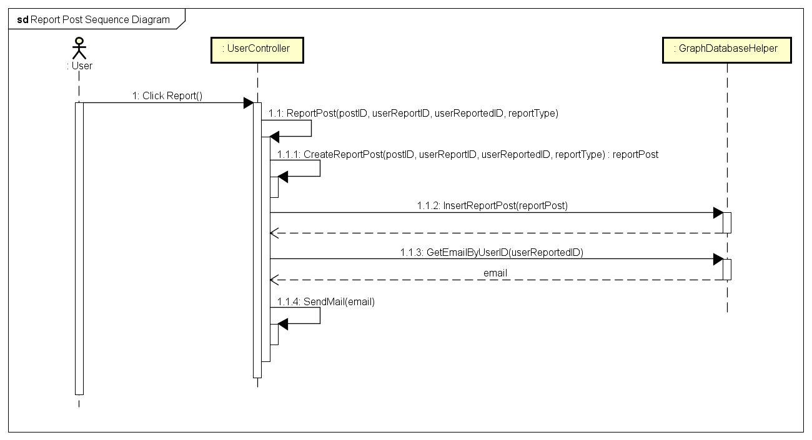

*Report a Post Sequence Diagram*

#### Report an user

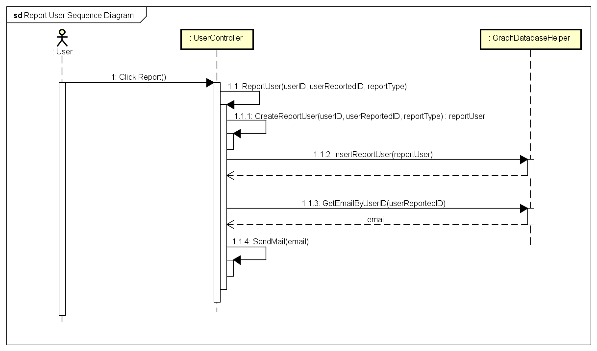

*Report an User Sequence Diagram*

## Chat

### Class Diagram

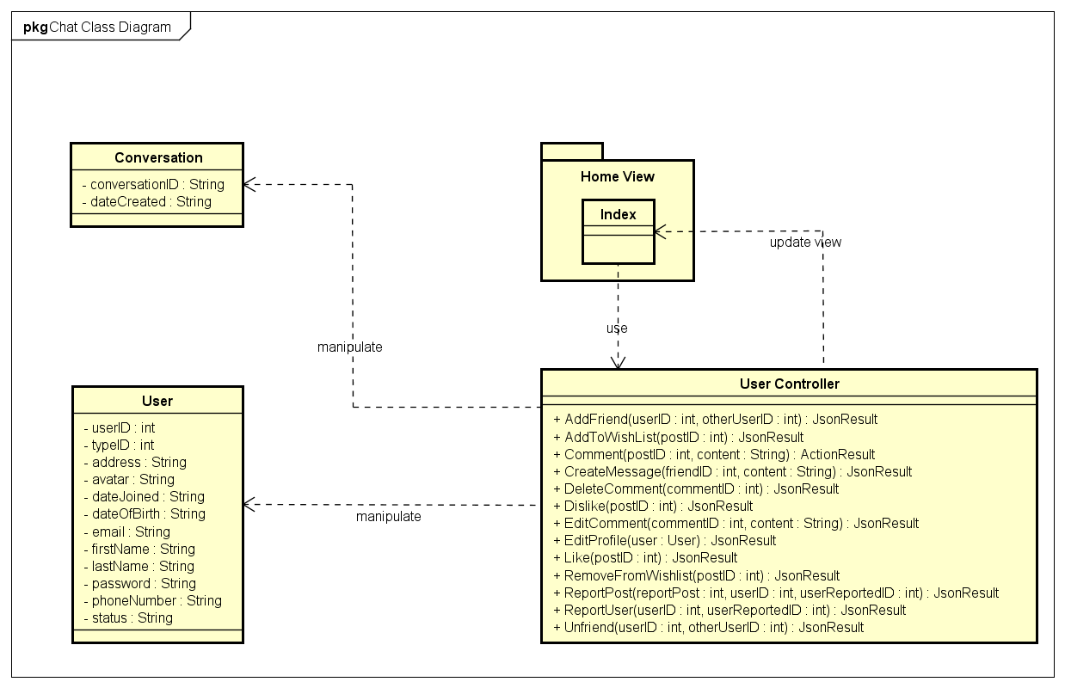

*Chat Class Diagram*

|  |  |  |
| --- | --- | --- |
| No. | Class Name | Description |
|  | User | Include method interact with Database |
|  | ReportPost | Include method interact with Database |
|  | ReportUser | Include method interact with Database |
|  | Index | Include method interact with Controller |
|  | User Controller | Include method interact with Model |

### User Class

#### Attributes

|  |  |  |  |  |  |
| --- | --- | --- | --- | --- | --- |
| No | Attributes | Type | Default | Note | Description |
|  | userID | int |  | public | User’s ID |
|  | typeID | int |  | public | User’s type, includes: Normal, Facebook, Google+ registered |
|  | address | String |  | public | User’s address |
|  | avatar | String |  | public | User’s avatar image |
|  | dateJoined | String |  | public | User’s joined date. Auto-created while registering |
|  | dateOfBirth | String |  | public | User’s date of birth |
|  | email | String |  | public | User’s email |
|  | firstName | String |  | public | User’s first name |
|  | lastName | String |  | public | User’s last name |
|  | password | String |  | public | User’s password |
|  | phoneNumber | String |  | public | User’s phone number |
|  | status | String |  | public | User’s status, includes: Lock and Active |

#### Methods

|  |  |  |  |  |
| --- | --- | --- | --- | --- |
| No. | Method | Input | Return | Description |
|  |  |  |  |  |

### Conversation Class

#### Attributes

|  |  |  |  |  |  |
| --- | --- | --- | --- | --- | --- |
| No | Attributes | Type | Default | Note | Description |
|  | conversationID | String |  | public | Conversation’s ID |
|  | dateCreated | String |  | public | Conversation’s created date. Auto-created while creating conversation |

#### Methods

|  |  |  |  |  |
| --- | --- | --- | --- | --- |
| No. | Method | Input | Return | Description |
|  |  |  |  |  |

### User Controller Class

#### Attributes

|  |  |  |  |  |  |
| --- | --- | --- | --- | --- | --- |
| No | Attributes | Type | Default | Note | Description |
|  |  |  |  |  |  |

#### Methods

|  |  |  |  |  |
| --- | --- | --- | --- | --- |
| No. | Method | Input | Return | Description |
|  | AddFriend | int, int | JsonResult | Add other users to friend list to get news, notification and messages |
|  | AddToWishlist | String | JsonResult | Add a post to wish list |
|  | Comment | int, String | ActionResult | Create a comment |
|  | CreateMessage | int, String | JsonResult | Send message to others |
|  | DeleteComment | int | JsonResult | Delete an owned comment |
|  | Dislike | int | JsonResult | Mark a post as dislike |
|  | EditComment | int, String | JsonResult | Edit content of an owned comment |
|  | EditProfile | user | JsonResult | Edit personal information |
|  | Like | int | JsonResult | Mark a post as liked |
|  | RemoveFromWishlist | int | JsonResult | Remove a post from wish list |
|  | ReportPost | int, int, int | JsonResult | Report a rule violation post |
|  | ReportUser | int, int | JsonResult | Report a rule violation user |
|  | Unfriend | int, int | JsonResult | Remove an user from friend list |

### Sequence Diagram

#### Chat

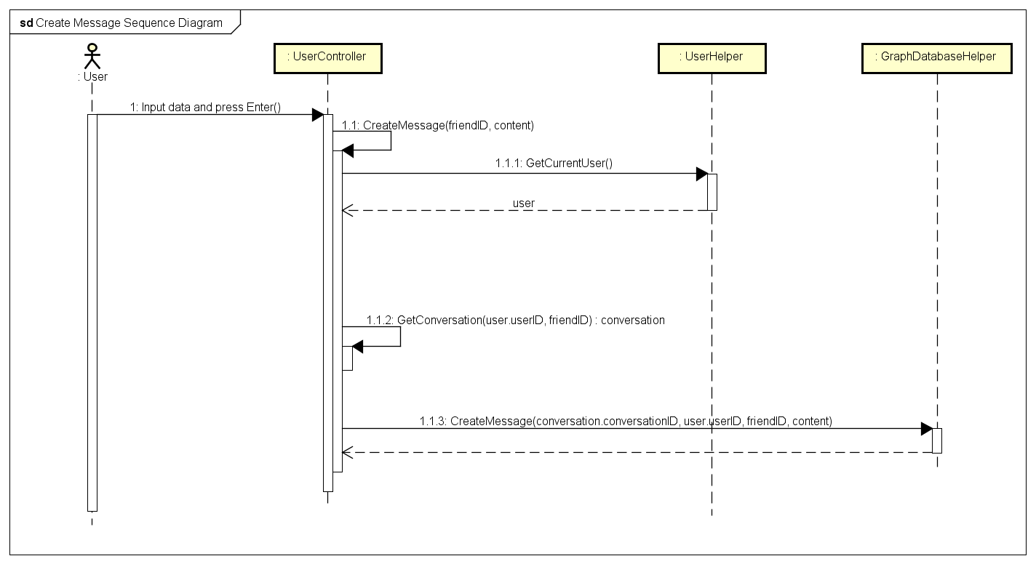

*Chat Sequence Diagram*

## Friend Management

### Class Diagram

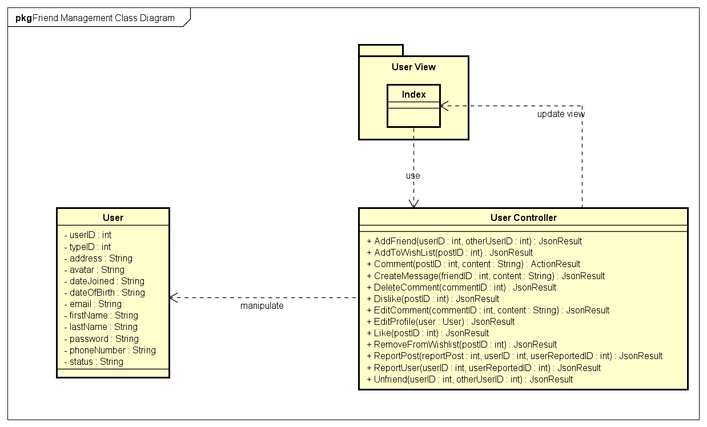

*Friend Management Class Diagram*

|  |  |  |
| --- | --- | --- |
| No. | Class Name | Description |
|  | User | Include method interact with Database |
|  | Index | Include method interact with Controller |
|  | User Controller | Include method interact with Model |

### User Class

#### Attributes

|  |  |  |  |  |  |
| --- | --- | --- | --- | --- | --- |
| No | Attributes | Type | Default | Note | Description |
|  | userID | int |  | public | User’s ID |
|  | typeID | int |  | public | User’s type, includes: Normal, Facebook, Google+ registered |
|  | address | String |  | public | User’s address |
|  | avatar | String |  | public | User’s avatar image |
|  | dateJoined | String |  | public | User’s joined date. Auto-created while registering |
|  | dateOfBirth | String |  | public | User’s date of birth |
|  | email | String |  | public | User’s email |
|  | firstName | String |  | public | User’s first name |
|  | lastName | String |  | public | User’s last name |
|  | password | String |  | public | User’s password |
|  | phoneNumber | String |  | public | User’s phone number |
|  | status | String |  | public | User’s status, includes: Lock and Active |

#### Methods

|  |  |  |  |  |
| --- | --- | --- | --- | --- |
| No. | Method | Input | Return | Description |
|  |  |  |  |  |

### User Controller Class

#### Attributes

|  |  |  |  |  |  |
| --- | --- | --- | --- | --- | --- |
| No | Attributes | Type | Default | Note | Description |
|  |  |  |  |  |  |

#### Methods

|  |  |  |  |  |
| --- | --- | --- | --- | --- |
| No. | Method | Input | Return | Description |
|  | AddFriend | int, int | JsonResult | Add other users to friend list to get news, notification and messages |
|  | AddToWishlist | String | JsonResult | Add a post to wish list |
|  | Comment | int, String | ActionResult | Create a comment |
|  | CreateMessage | int, String | JsonResult | Send message to others |
|  | DeleteComment | int | JsonResult | Delete an owned comment |
|  | Dislike | int | JsonResult | Mark a post as dislike |
|  | EditComment | int, String | JsonResult | Edit content of an owned comment |
|  | EditProfile | user | JsonResult | Edit personal information |
|  | Like | int | JsonResult | Mark a post as liked |
|  | RemoveFromWishlist | int | JsonResult | Remove a post from wish list |
|  | ReportPost | int, int, int | JsonResult | Report a rule violation post |
|  | ReportUser | int, int | JsonResult | Report a rule violation user |
|  | Unfriend | int, int | JsonResult | Remove an user from friend list |

### Sequence Diagram

#### Add Friend

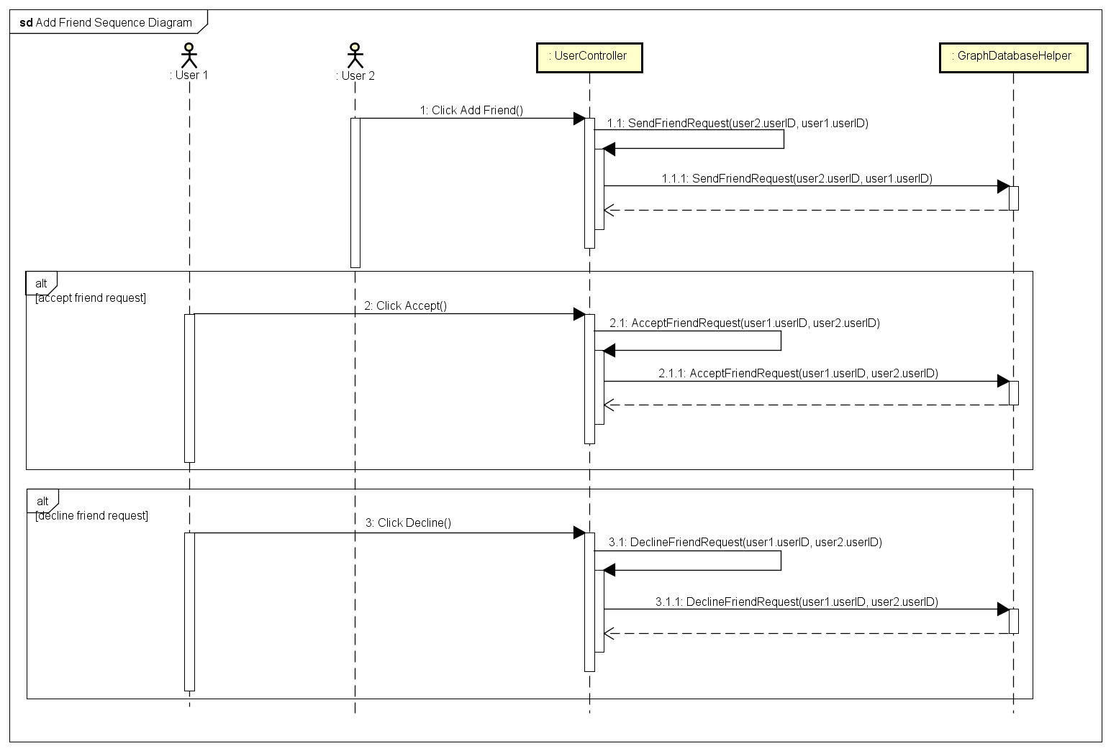

*Add Friend Sequence Diagram*

#### Unfriend

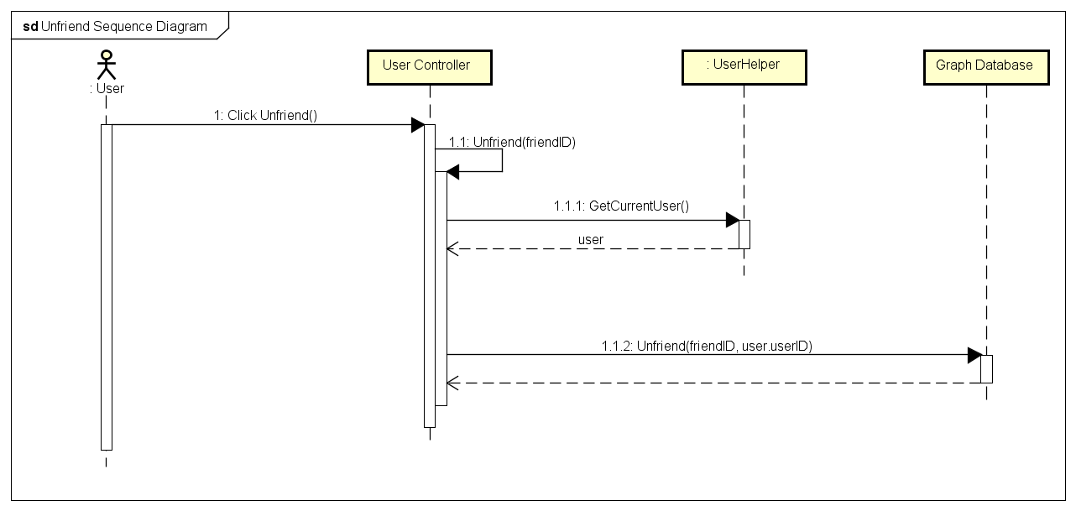

*Unfriend Sequence Diagram*

## Room (Undone)

## Account Management

### Class Diagram

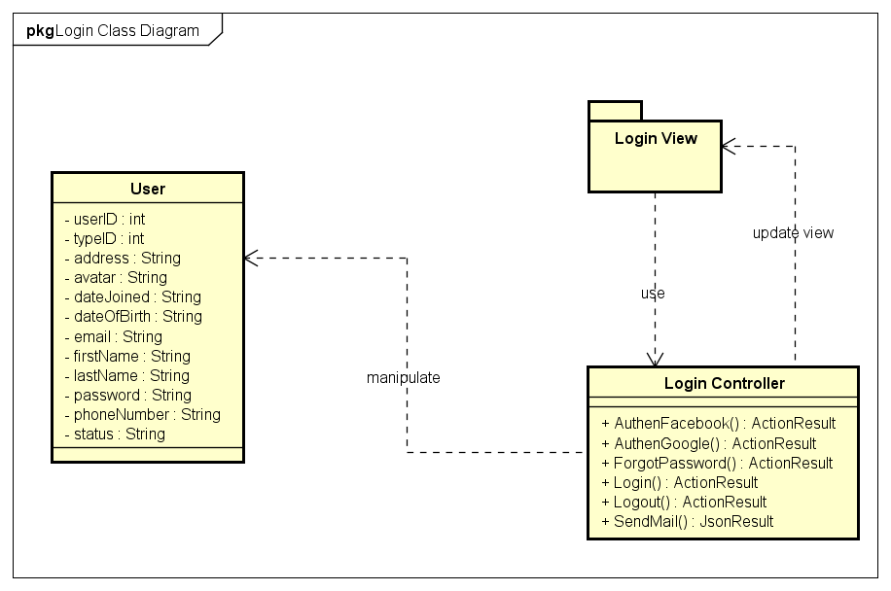

*Account Management Class Diagram*

|  |  |  |
| --- | --- | --- |
| No. | Class Name | Description |
|  | User | Include method interact with Database |
|  | Login | Include method interact with Controller |
|  | Login Controller | Include method interact with Model |

### User Class

#### Attributes

|  |  |  |  |  |  |
| --- | --- | --- | --- | --- | --- |
| No | Attributes | Type | Default | Note | Description |
|  | userID | int |  | public | User’s ID |
|  | typeID | int |  | public | User’s type, includes: Normal, Facebook, Google+ registered |
|  | address | String |  | public | User’s address |
|  | avatar | String |  | public | User’s avatar image |
|  | dateJoined | String |  | public | User’s joined date. Auto-created while registering |
|  | dateOfBirth | String |  | public | User’s date of birth |
|  | email | String |  | public | User’s email |
|  | firstName | String |  | public | User’s first name |
|  | lastName | String |  | public | User’s last name |
|  | password | String |  | public | User’s password |
|  | phoneNumber | String |  | public | User’s phone number |
|  | status | String |  | public | User’s status, includes: Lock and Active |

#### Methods

|  |  |  |  |  |
| --- | --- | --- | --- | --- |
| No. | Method | Input | Return | Description |
|  |  |  |  |  |

### Login Controller Class

#### Attributes

|  |  |  |  |  |  |
| --- | --- | --- | --- | --- | --- |
| No | Attributes | Type | Default | Note | Description |
|  |  |  |  |  |  |

#### Methods

|  |  |  |  |  |
| --- | --- | --- | --- | --- |
| No. | Method | Input | Return | Description |
|  | AuthenFacebook |  |  | User login with Facebok |
|  | AuthenGoogle |  |  | User login with Google+ |
|  | ForgotPassword |  |  | Set user’s password to a random string and send to user |
|  | Login |  |  | User login with registered account |
|  | Logout |  |  | User logout from FAP |
|  | SendMail |  |  | Send mail to user |

### Sequence Diagram

#### Login (Undone)

#### Logout

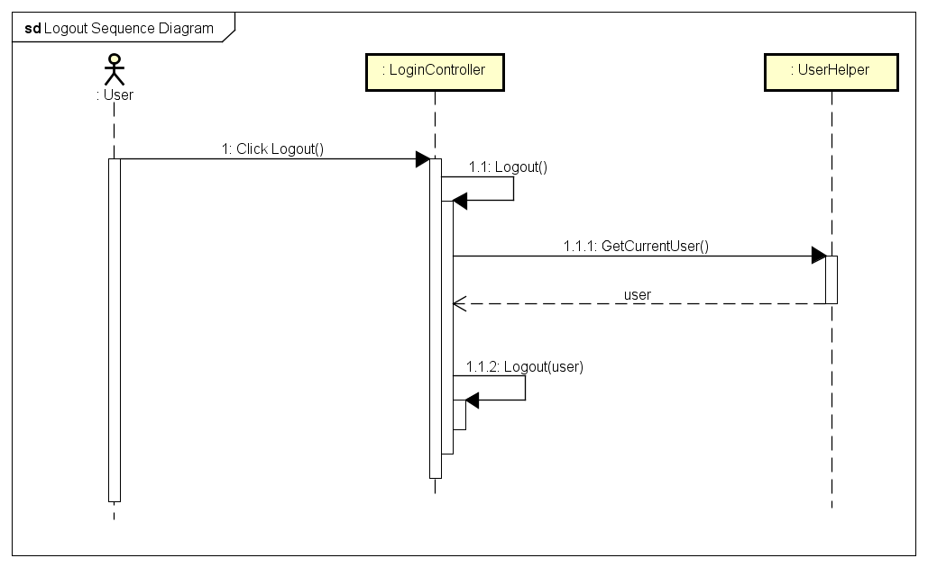

*Logout Sequence Diagram*

#### Register (Undone)

#### Edit Profile

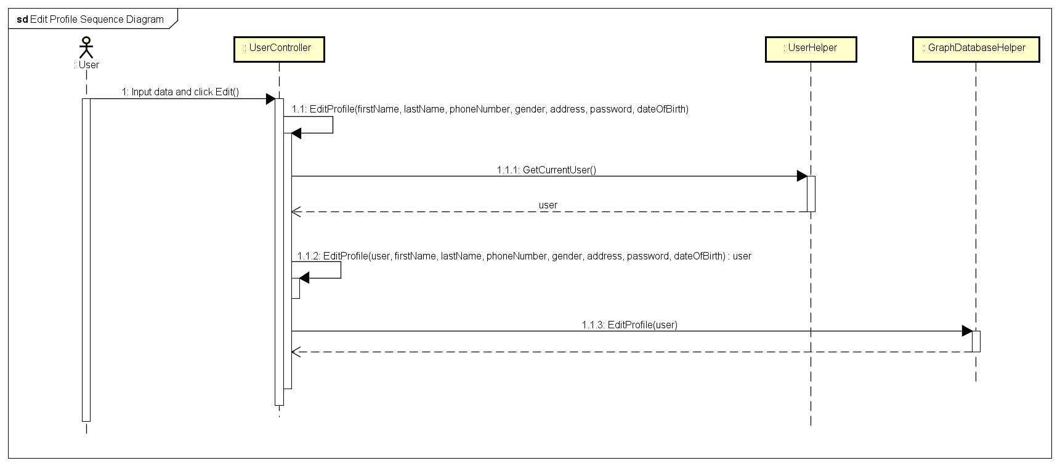

*Edit Profile Sequence Diagram*

#### Forgot Password

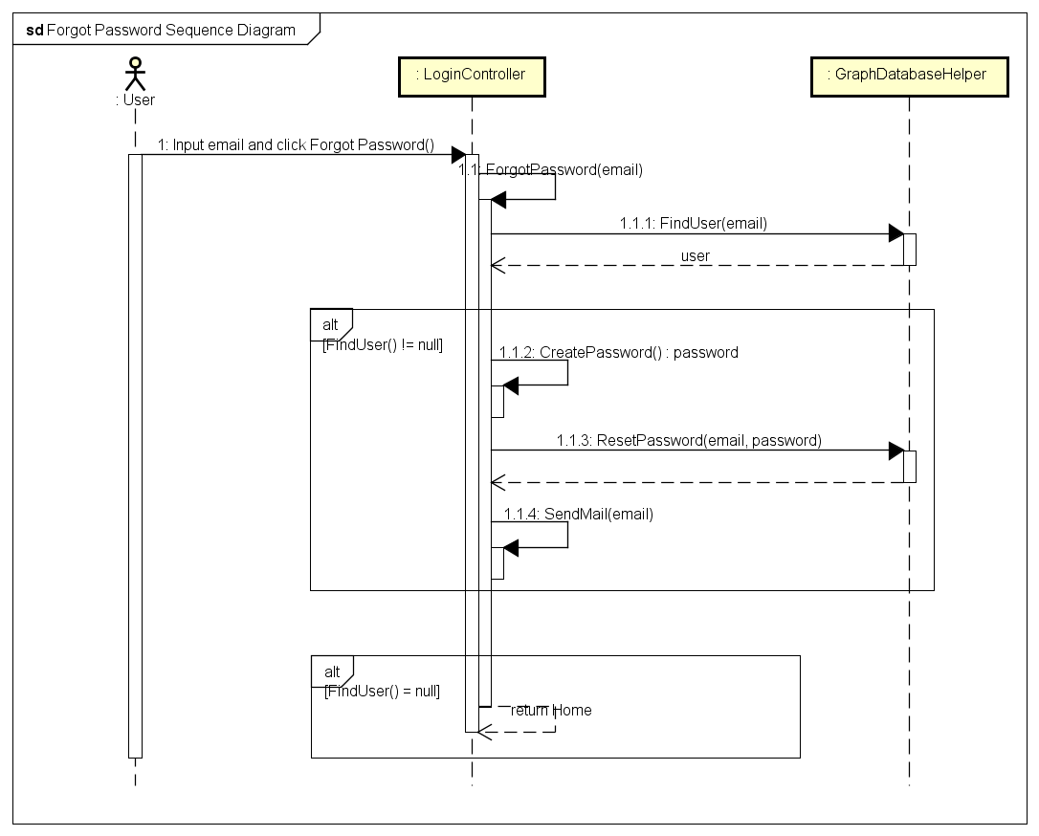

*Forgot Password Sequence Diagram*